Data 620 – Spring 2018

Assignment 12 – Tesla Inc. Shareholder Letter Analysis

Kenneth Lulie

Professor Majed Al-Ghandour

University of Maryland University College

April 21, 2018

**Executive Summary**

A shareholder letter is written by a public company’s top leadership to the stockholders of that company, usually on a quarterly or annual basis (Investopedia, 2018). These letters are written to communicate the status of the company, and will cover subjects such as the firm’s financial performance, changes in the company’s stock price or finances, and guidance to the future. The purpose of this paper is to analyze Tesla Inc. Shareholder Letters from 1Q12, 1Q15, and 4Q17 via word frequency text analysis to ascertain if this technique can quickly gain insights into a company without extensive research. If successful, word frequency analysis could be used to help researchers quickly identify key information regarding a company before investing time in extensive research.

Our analysis shows that the word frequency analysis of Tesla’s shareholder letters correlates strongly to the well-known story of Tesla Inc. The word frequency text analysis for the 1Q12 letter identified the priorities of the company at the time, specifically the focus on securing financing and launching the Model S electric sedan. The text analysis of 1Q15 showed the focus was still on the Model S, but as a matured product line. The analysis for 4Q17 shows that the current priority of the company is the mass production of the Model 3 electric car, as well as energy in the form of batteries and solar panels. Based on the success in the analysis of Tesla shareholder letters it appears that word frequency analysis could be a useful tool to assist researchers.

**Tesla’s Story is Financing and Manufacturing**

Tesla Inc. is an American based automotive company which specializes in producing electric vehicles. Since Tesla’s founding in 2003, it has grown to a publically listed company with a market capitalization of fifty billion dollars and over 30,000 employees. Due to being publically traded, as well as its ambitious goal of making electric vehicles affordable to the average consumer there has been a great deal of interest in the company’s progression (LA Times, 2015).

As far back as 2006, the CEO of Tesla, Elon Musk, posted a ‘master plan’ for the company’s future (Tesla, 2006). This plan essentially was to produce a luxury electric car, the Model S, with high profit margins to allow Tesla to develop expertise and manufacturing capabilities. Using the profits, and experience gained from the successful production of this luxury car line they would then turn to producing a mass market electric vehicle, which ended up being called the Model 3.

Using a word frequency text analysis on the company’s letter to shareholders issued for 1Q12, 1Q15, and 4Q17 we can examine the 30 most frequently used words for each letter and their rate of occurrence and compare this to the well-known Tesla story to see if word frequency analysis can quickly show the most essential information on a company and help guide where to research.

A packed bubble visualization of the combined data from all 3 letters (see Figure 1 below) shows that the most important themes in these letters, as might be expected in a document to shareholders, focuses on the financials of the company with words such as “Cash”, “Operating”, “Net”, “Million” “Loss” and “Expense” being prominent. Another major theme the 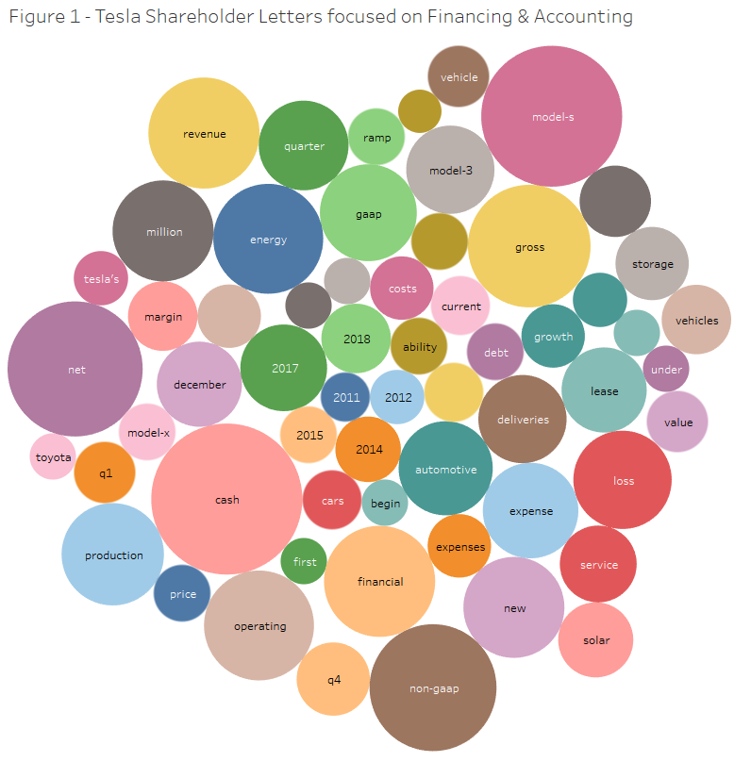

bubble shows is one of production and deadlines, with “Model S”, “December”, “Quarter” and “Deliveries” standing out. This matches well with the focus of Tesla investors, which is understanding how well Tesla is doing at ramping up manufacturing and delivery of their vehicles. Without reading the letters, we can see what has been important to Tesla over the years.

**1Q12 Letter focuses on Launch of Model S**

The word frequency analysis of the 1Q12 Shareholder letter (See Figure 2 below) shows the focus on company finances expected in a letter to shareholder, with “financial”, “non-GAAP”, and “cash” taking three of the top five ranks by work frequency. While financial and cash seem obvious, the inclusion of non-GAAP leads us to a valuable part of Tesla’s financial 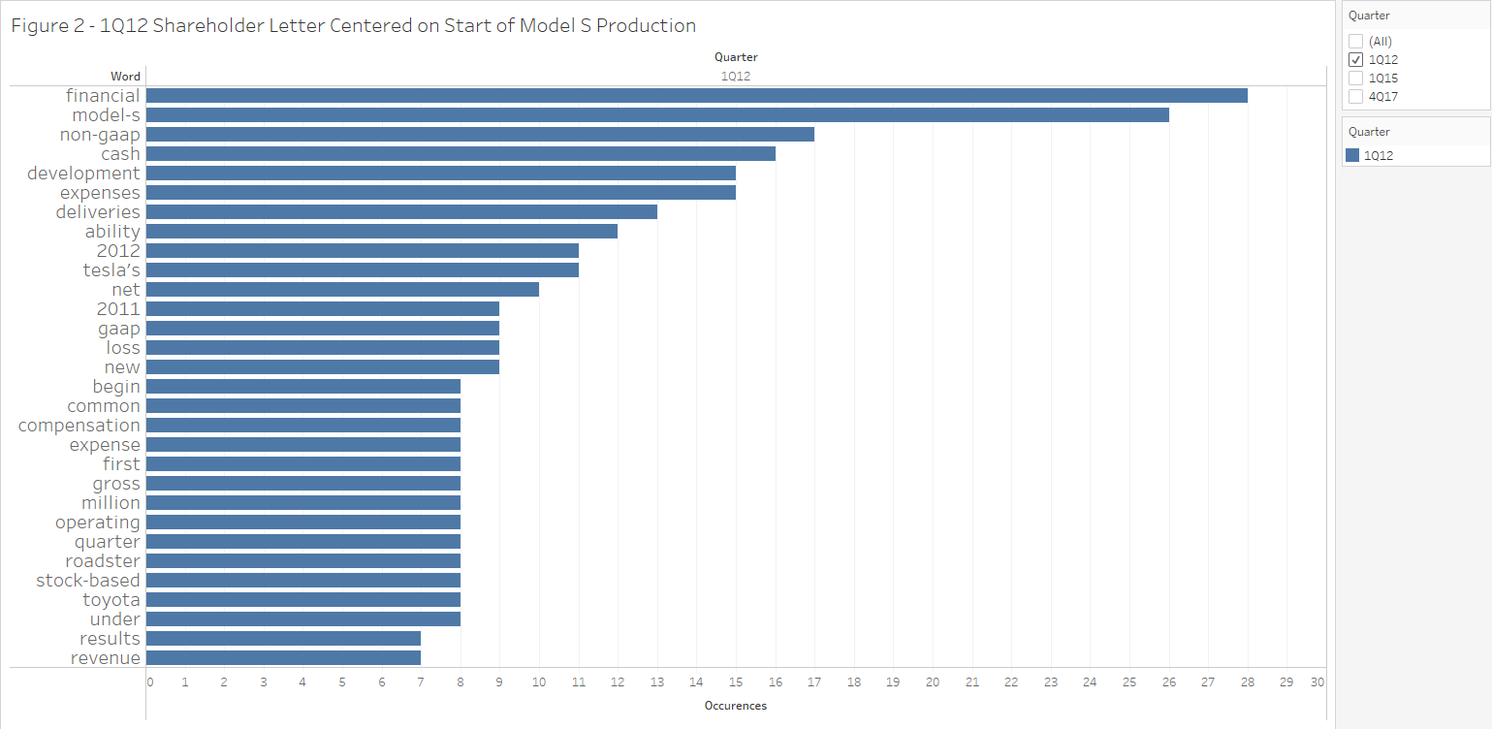 strategy. GAAP, or generally accepted accounting principles, is an international standard of corporate accounting which allows investors to understand companies financial reports (Accounting, 2018). Tesla was involved in a controversy due to offering additional non-GAAP financial reporting as a way of showing investors alternate ways to look at their projected revenue. However, the Securities and Exchange Commission (SEC) issued a warning to Tesla about this practice in 2016 causing Tesla to make changes to its non-GAAP reporting (Shen, 2016).

Another area of interest revealed by the word frequency analysis is the launch of the Model S line of luxury car with the words “Model S”, “development”, and “deliveries” all receiving a high number of mentions. As the Model S was about to being deliveries the next quarter, much attention was being given as to how quickly Tesla could begin deliveries and at what rates (Cobb, 2012). Together, the analysis gives a quick picture at the state of Tesla in the first quarter of 2012 with attention being given on financing so it could invest in the future along with all eyes on the first production line car the company would produce.

**1Q15 Letter Shows Eyes on Maturing Model S Production**

The word frequency analysis of the 1Q15 Tesla shareholder letter (See Figure 3 below)

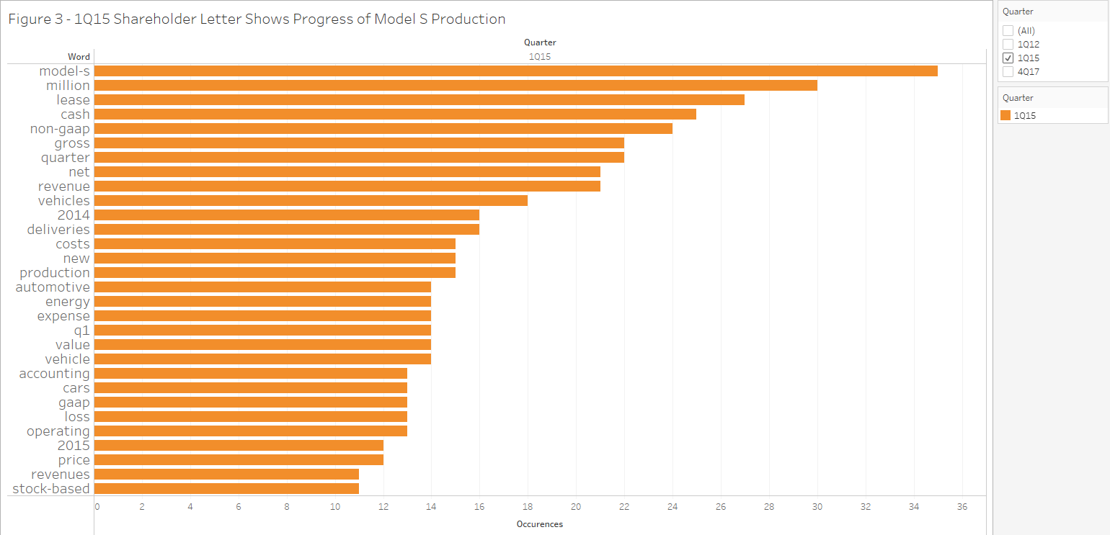

shows that attention is still focused on the same two themes of financial reporting and Model S shown in 1Q12. This shows the state of the company still being divided between car manufacturing and raising enough money to finance the car manufacturing. However, this time Model S has taken the lead as the most mentioned word, and lease has jumped in the list to rank 3. This reflects the status of the company at the time.

Raising enough money to invest in development and manufacturing assets was still essential but the focus changed to examining how well Tesla’s first major car line, the Model S, was doing. The Model S had entered its third year of production and close attention was being given to its profit margin, which is why “lease” entered the list so highly (Tully, 2016). A large proportion of income from the Model S was based on leasing revenue, and a large proportion of the letter was tied into reporting leasing revenue through non-GAAP accounting (Tesla, 2015). Once again, the word frequency analysis can quickly show the major themes of a letter before additional research is done.

**4Q17 Letter shows Shift to Model 3 and Solar & Battery Production**

The word frequency analysis of the latest Tesla Shareholder letter (See Figure 4 below),

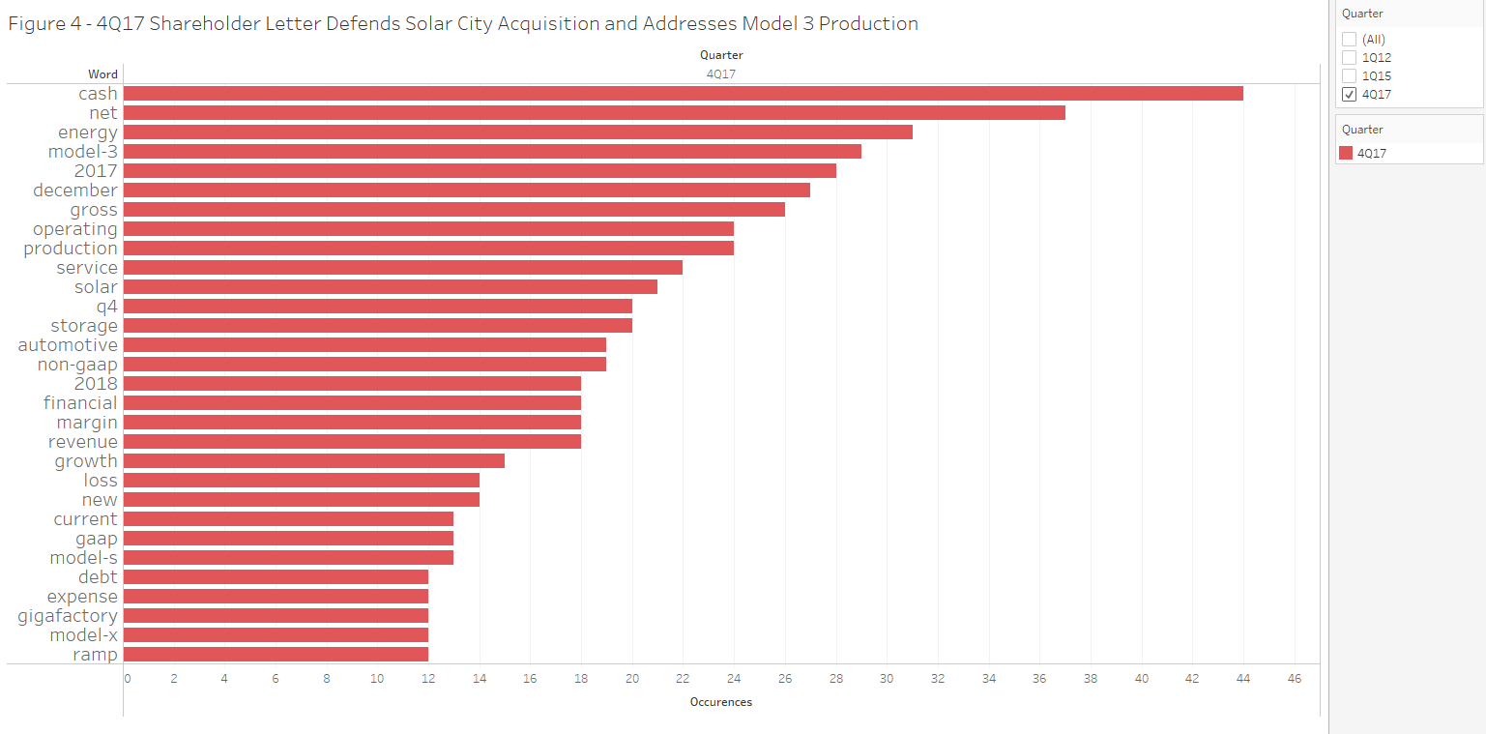shows a change in the non-financial focus of the letters. Where as in the first two letters the Model S was one of the most prominent themes, the Model 3 is now in the top 5 list of words while Model S has fallen to rank 25. The increased frequency of Model 3, and the decrease in attention to the Model S is an accurate snapshot of the state of Tesla today. The Model S line has matured in 2018, six years after it started production. Meanwhile, the Model 3 mass production entry level electric car is now the main focus of Tesla (Mak, 2018). Tesla has continued to miss production deadlines for the volume of the Model 3, and concerns about missing production level deadlines are reflected by the introduction of “Ramp” to our list at rank 30 as the letter talks about Tesla’s attempts to ramp up Model 3 production (Tesla, 2018).

Additionally, the word “energy” is now the third most mentioned word, up from rank 16 in 1Q15. Other related words are “gigafactory” and “solar”. This represents Tesla’s acquisition of Solar City, a solar panel manufacturer and installer, as well as the introduction of the Gigafactory for large scale battery production (Tesla, 2018). This is part of Tesla’s new plan to be able to sell a consumer an electric car, a battery for their house, and even solar panels to help power it all. Once again, the text analysis does an adequate job of quickly showing the concerns and focus of the company without reading the letter.

**Tesla Shifts Focus from Model S to Model 3 as well as Solar Power and Energy**

When viewing the changes in word frequency as a whole from 1Q12, to 1Q15, to 4Q17 (See Figure 5 below) we can see the change in what is most important to the company. Four

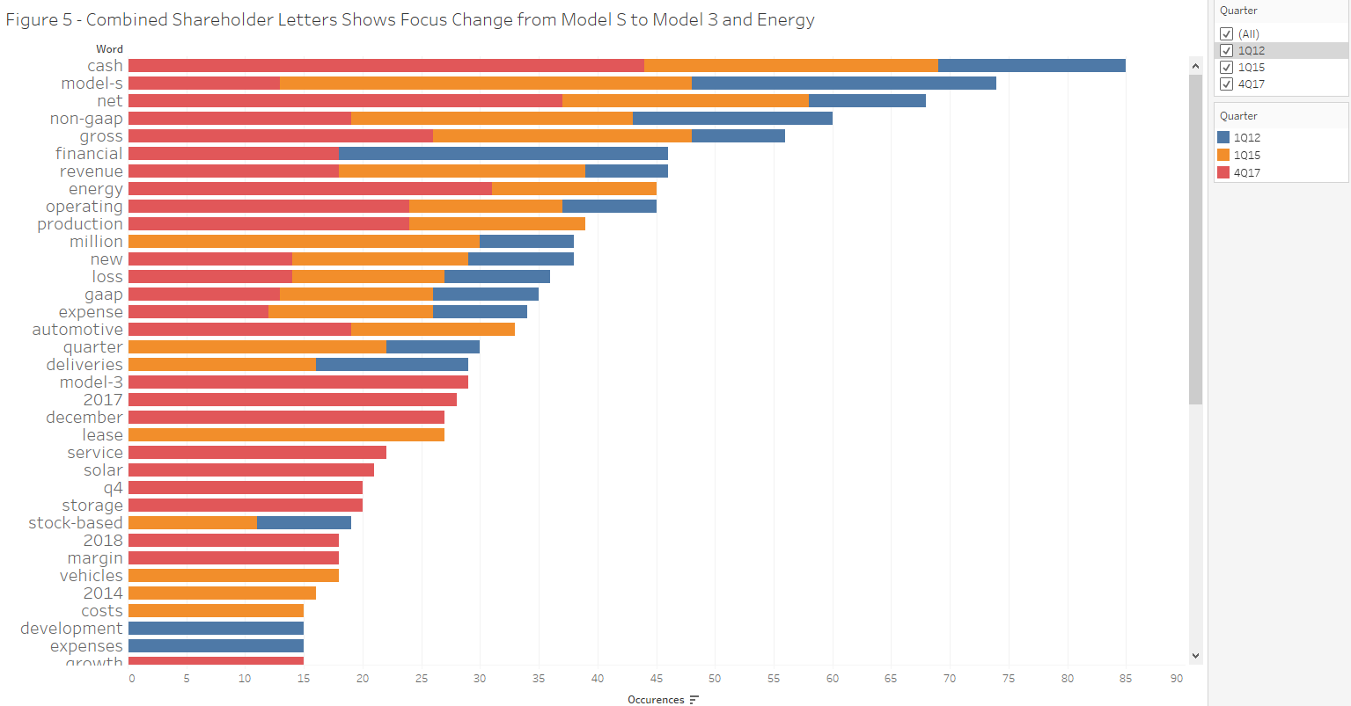 major words jump out in importance. “Model S” changed from being a major focus of 1Q12 and 1Q15 as the product launched to a side show in 4Q17 as the mature product line requires less attention. We see “Energy” going from not even in the top 30 in 1Q12, to of moderate importance in 1Q15, to taking a star role in the 4Q17 report after the acquisition of Solar City. We can see “Model 3” go from ‘zero’, with no mentions in 1Q12 or 1Q15 to ‘hero’, with a major focus in 4Q17 as the company pins its long term future on its ability to manufacture the car in large scales (Tesla, 2018). Finally, we can see the maturing of the company from ‘start-up’ to major manufacturer with “production” going from under rank 30 in 1Q12, to high importance in 1Q15 and 4Q17 as the company started mass production of different car lines.

**Word Frequency Analysis Suitable Tool for Research**

The word frequency analysis of Tesla letters to shareholders in 1Q12, 1Q15, and 4Q17 showed that this simple technique was able to produce a list of what was most important to the company throughout each time period. These types of lists are easy to produce, and easy to read while providing a starting point to understanding and researching a company. This type of analysis would be useful to offer to researchers so that they can not only save time, but possibly look for unique and unexpected insights.

.

**References**

**DATA SOURCE** - <http://ir.tesla.com/downloads.cfm?view=all>

Cobb, J., & Prince, R. (2012, December 11). Tesla Model S Launches Today. Retrieved from http://www.hybridcars.com/tesla-model-s-launches-today-47425/

 Denning, L. (2018, April 19). Tesla's Cash Burn Has Elon Musk's Dreams Living on Borrowed Time. Retrieved from <https://www.bloomberg.com/news/articles/2018-04-19/tesla-s-cash-burn-has-elon-musk-s-dreams-living-on-borrowed-time>

*Hirsch, Jerry (2015-03-19).*["Elon Musk: Model S not a car but a 'sophisticated computer on wheels'"](http://www.latimes.com/business/autos/la-fi-hy-musk-computer-on-wheels-20150319-story.html)*.*[Los Angeles Times](https://en.wikipedia.org/wiki/Los_Angeles_Times). Retrieved 2015-05-09*.*

Mak, A. (2018, April 02). Elon Musk Is Personally Taking Over Production of Tesla's Much-Delayed Model 3. Retrieved from <https://slate.com/technology/2018/04/teslas-model-3-production-will-now-be-personally-overseen-by-elon-musk-report.html>

The Secret Tesla Motors Master Plan (just between you and me). (2012, June 29). Retrieved https://www.tesla.com/blog/secret-tesla-motors-master-plan-just-between-you-and-me

Tully, Shawn (2016, September 2) Why Tesla's Cash Crunch May Be Worse Than You Think. (n.d.). Retrieved from http://fortune.com/2016/09/02/elon-musk-tesla-cash-crunch-worse-than-you-think/

Staff, I. (2018, February 01). Shareholder Letter. Retrieved from <https://www.investopedia.com/terms/s/shareholder-letter.asp>

The Comprehensive Guide to Understanding GAAP. (n.d.). Retrieved from <http://www.accounting.com/resources/gaap/>